Minor Project – Finite Element Method

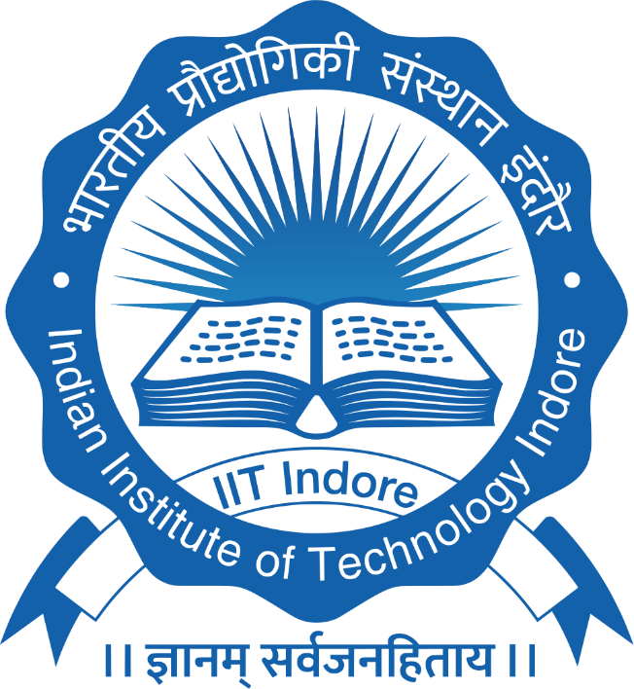

Course Coordinator: Dr. Sandeep Singh
Course Code: ME 436/736

Name: Abhishek Yadav
Roll no.: 2502103031
Department: Mechanical Engineering
Discipline: Thermal Energy Systems

